Guided Practice Report
Before completing this guided practice report, you should have completed the associated procedure.

Screenshots
After you have completed the procedure for the guided practice, add your screenshots below.
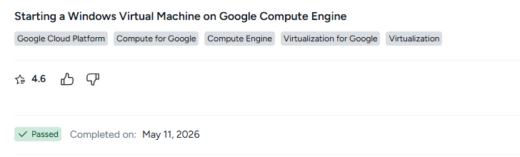

Reflection Questions
After you have completed the procedure for the guided practice, provide your answers to the reflection questions here.
Why was a recovery e-mail address required along with your username and password credentials when you signed-in to the Google Cloud environment?
A recovery e-mail address was required to add an extra layer of security. It helps verify your identity, recover your account if you forget your password, and protect your Google Cloud account from unauthorized access.

